Outputs
Task: 1 The raining House
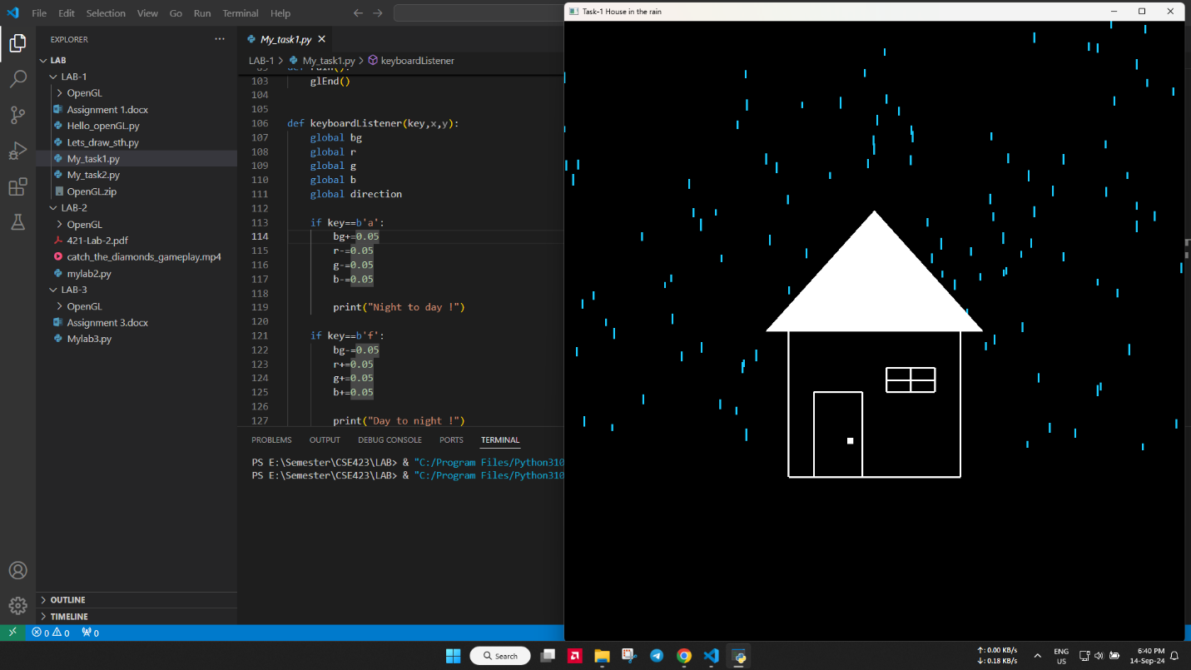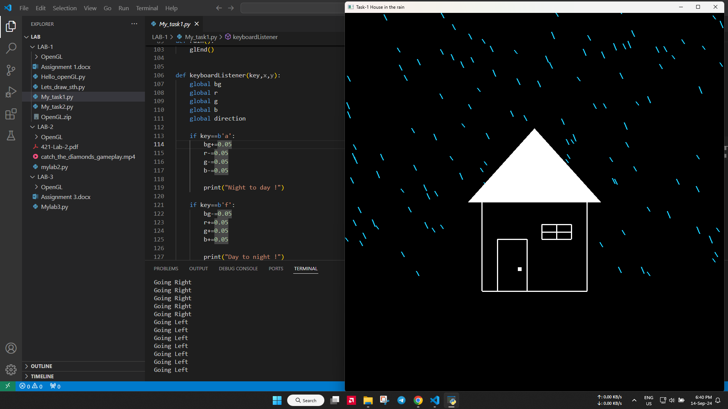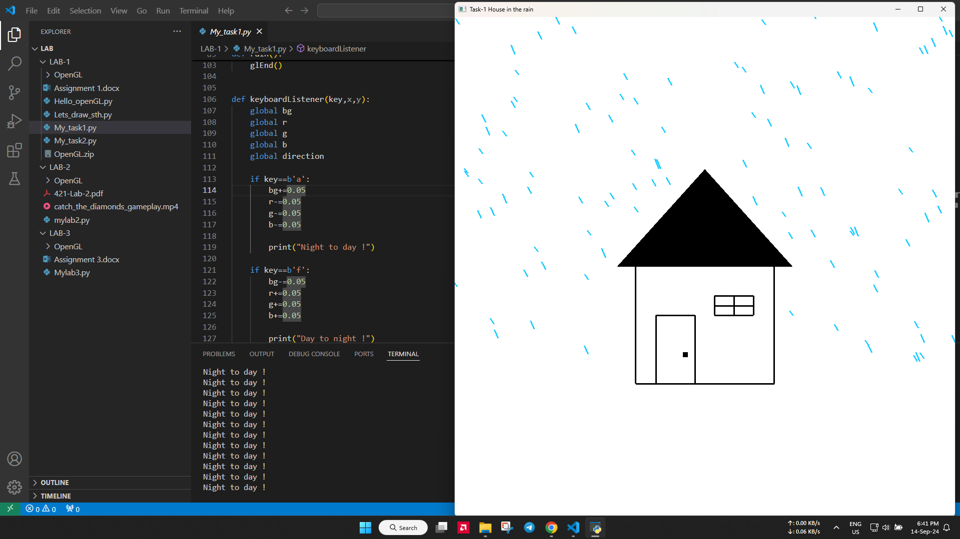
Code:
https://colab.research.google.com/drive/1tt2kJuCt6rouv4AkRN_8tGB3oRVQFTSk?usp=sharing

Task:2
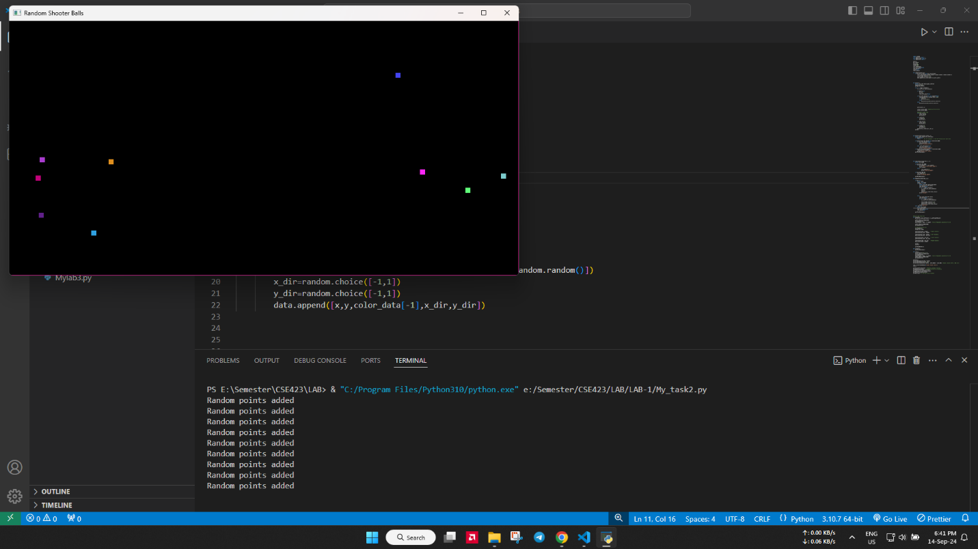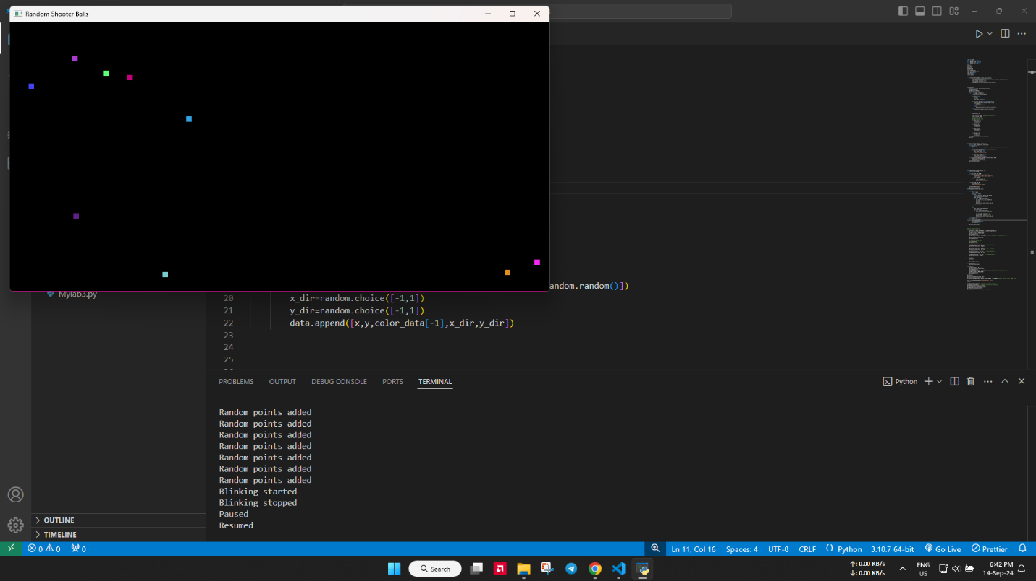

Code:
https://colab.research.google.com/drive/1tt2kJuCt6rouv4AkRN_8tGB3oRVQFTSk#scrollTo=tTsuVrlclf_t&line=14&uniqifier=1

